LET’S GO TO NEXUS ARTS!

This guide will help us get there.

This is an easy-to-read guide on how to visit Nexus Arts.

It is also in large print.

Where is Nexus Arts?
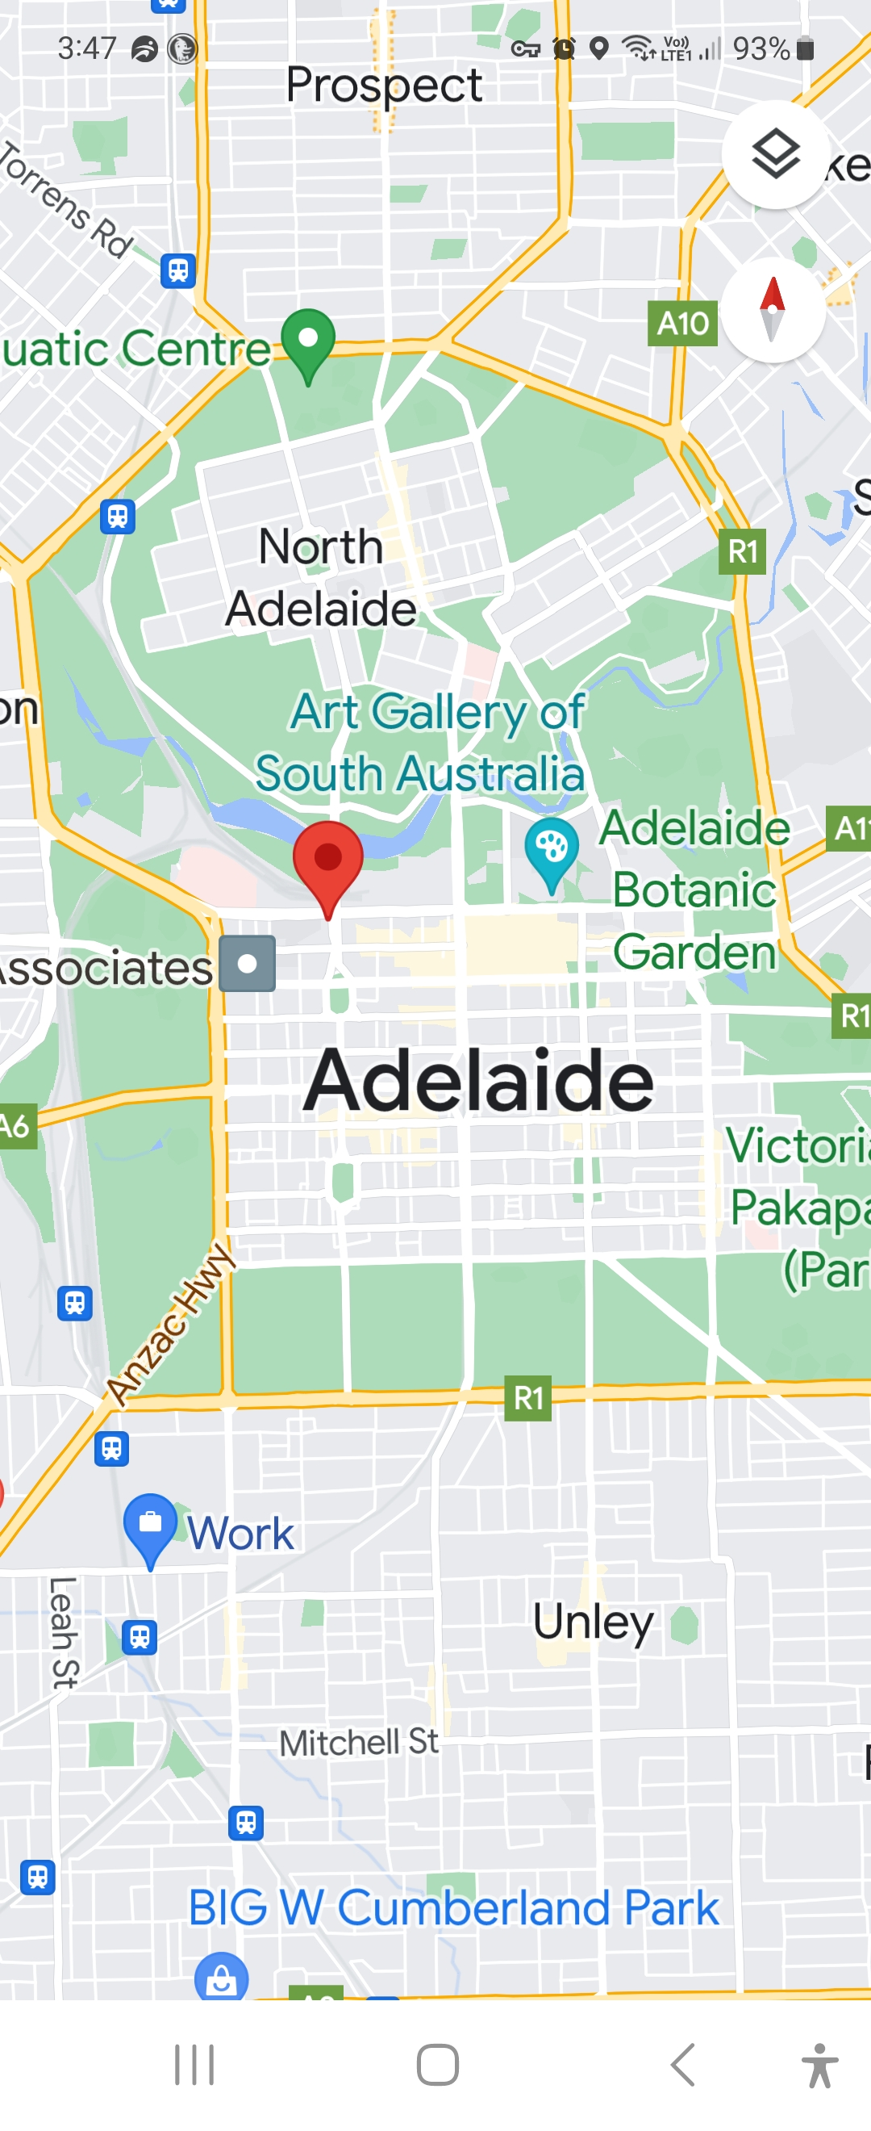
It is in the city of Adelaide.
It is part of the Lion Arts Centre at the west end of the city.
The Lion Arts Centre is at the corner of Morphett Street and North Terrace – on the south side.

Where is Nexus Arts in the Lion Arts Centre?
There are two easy ways to find Nexus Arts in the Centre.
FROM THE SOUTH SIDE OF NORTH TERRACE
This is the best way to enter if you come from the TRAM, the BUS and TRAIN. SEE the “GETTING HERE” section on pages 5-9.
- Look for the FOWLER’S BUILDING. It is a large red brick building with a sign that reads ‘Lion Arts Factory’. It has a sculpture coming out of the windows that looks like spilt yellow paint.
- On the other side of the entrance is the UniSA CITY WEST campus.
- Enter South between these two buildings into a courtyard.
- Once you pass the Fowler building on your left-hand side, you will see Nexus Arts. Nexus Arts has the Gallery down a level from the courtyard. It also has the Venue which is further along on the courtyard level.
- You can get to Nexus Arts Gallery on the left-hand side by a ramp or by stairs.
- You can get to Nexus Arts Venue by going south a bit more. It is on the left-hand side. You can get to it by a small set of stairs and a ramp access just a little bit further along the entrance.

FROM THE WEST SIDE OF MORPHETT STREET (under the bridge).
This is the best way to come if you use the disabled car park or come by bicycle or motorbike.
It also the best way to come from Hindley Street. Also, from the bus stops on Grenfell Street.
- Look for the JAM FACTORY. This building has a glass front. It will be on your left side when going west.
- Look for the MERCURY CINEMA. This will be on your right.
- Enter the Lion Arts Centre precinct between these two buildings.
- Follow the path around to the right.
- Look for GUILDHOUSE and MERCURY CX entrances on the right.
- Keep going North as just past them on the right-hand side is Nexus Venue.
- Keep going North. On the right-hand side is the entrance to the ramp and stairs to Nexus Gallery.

Getting Here

BY TRAM
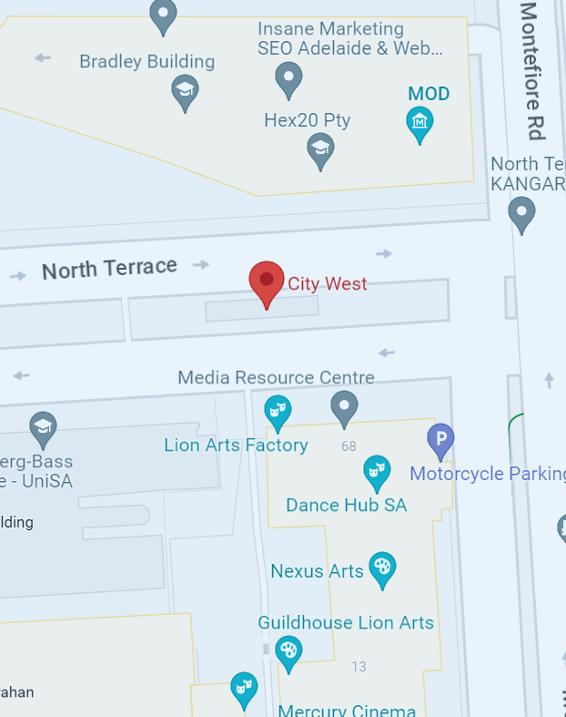
The closest tram stop is City West on North Terrace.
It is about 70m away from Nexus Arts.
When you get off the tram, you must cross to the South side of North Terrace. There is a crossing with lights.
Then you follow the steps under FROM THE SOUTH SIDE OF NORTH TERRACE written above.

BY BUS
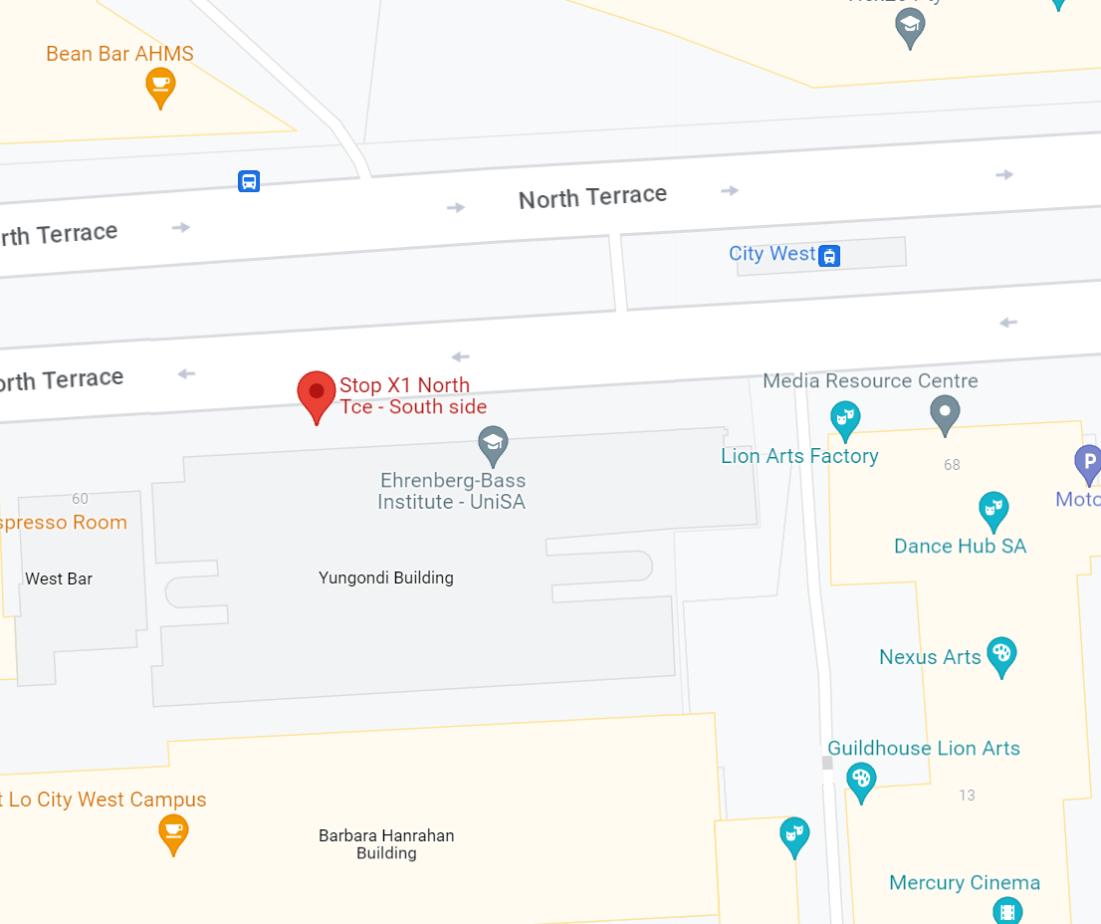

The closest bus stop is X1. It is on the South side of North Terrace.
It is about 70m away from Nexus Arts.
Nexus Arts is a short walk away from bus stops on Grenfell Street. Follow the steps under FROM THE WEST SIDE OF MORPHETT STREET written above.

BY TRAIN
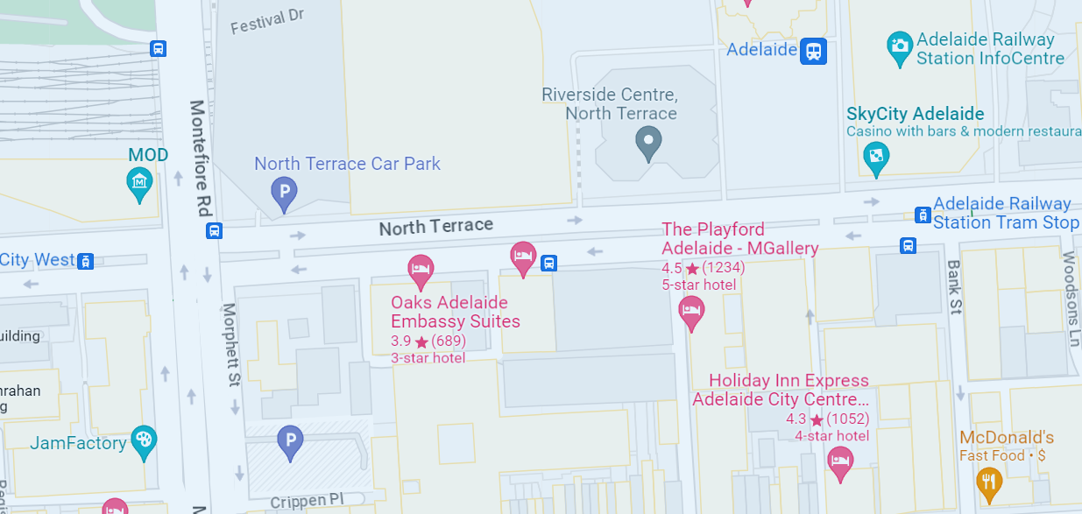
You can walk from Adelaide Railway Station to Nexus Arts. It will take about 10 minutes.
When you leave the railway station, you turn right onto North Terrace.
Then head West for about 600 metres and cross the road to the South side of North Terrace.
Then you follow the steps under FROM THE SOUTH SIDE OF NORTH TERRACE written above.

BY BIKE
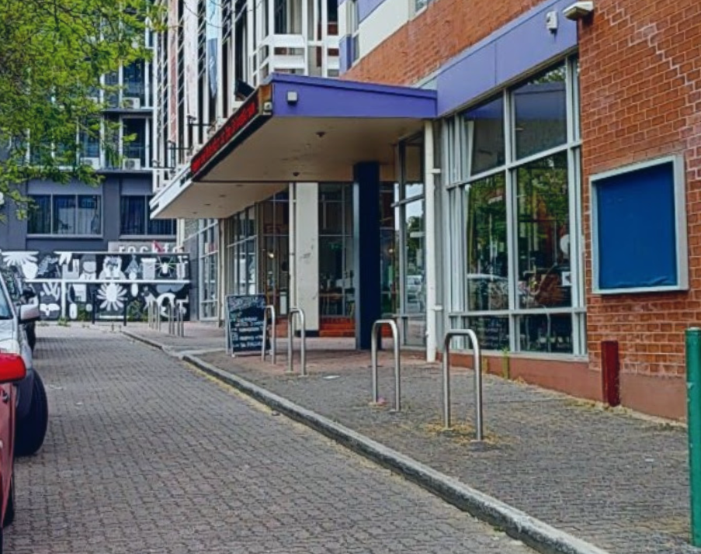
There is bicycle parking at the Morphett Street entrance.
It is in front of the Jam Factory and Mercury CX buildings.

BY MOTORBIKE

There is motorbike parking under the bridge at the Morphett Street entrance.
It is opposite the front of the Jam Factory and Mercury CX buildings.

BY CAR
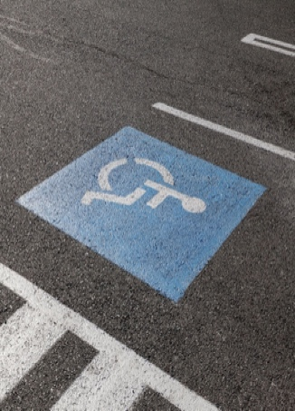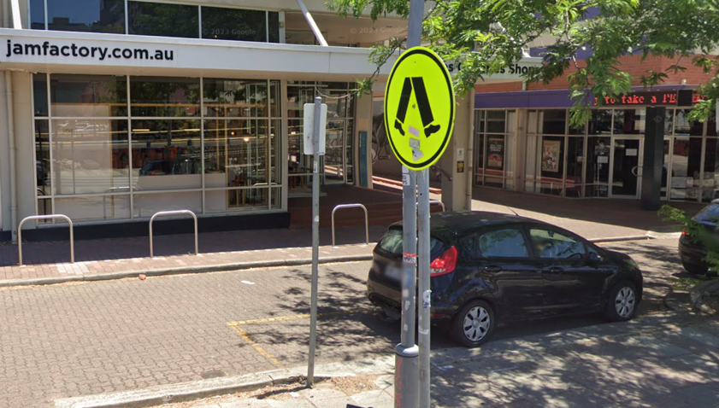
There is an accessible car park at the Morphett Street Entrance.
It is in front of the Jam Factory and Mercury Cinema.
There is a limited amount of street parking spaces. You need to buy a ticket for these.
There are many pay-by-the-hour car parks located on Hindley Street. Both to the East and West of the Lion Arts Precinct.

IF YOU NEED HELP YOU CAN:

CALL NEXUS ARTS on (08) 8212 4276.

EMAIL NEXUS ARTS on info@nexusarts.org.au

