TRANSPORT TO NEXUS ARTS!

This guide will help us get there.

This is an easy-to-read guide on getting to Nexus Arts.

It is also in large print.

Where is Nexus Arts?
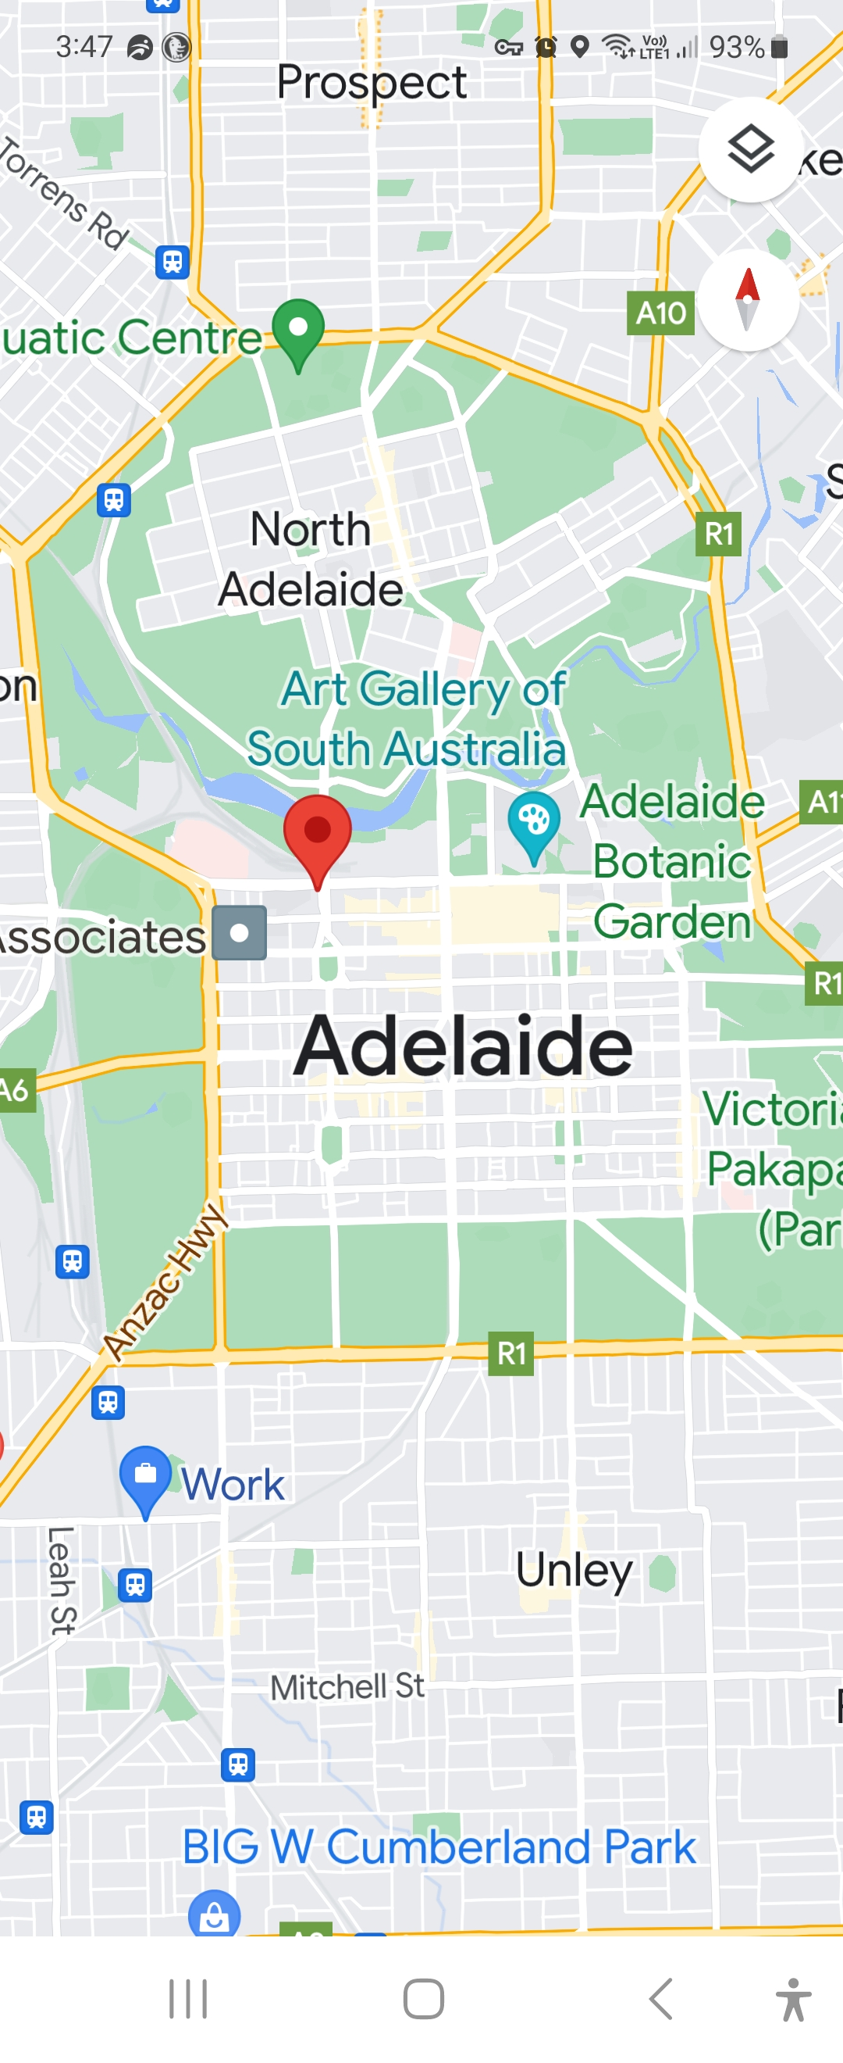
It is in the city of Adelaide.
It is part of the Lion Arts Centre at the west end of the city.
The Lion Arts Centre is at the corner of Morphett Street and North Terrace – on the south side.
Visit the EASY GUIDE on the FIND US webpage.

Getting Here

BY TRAM
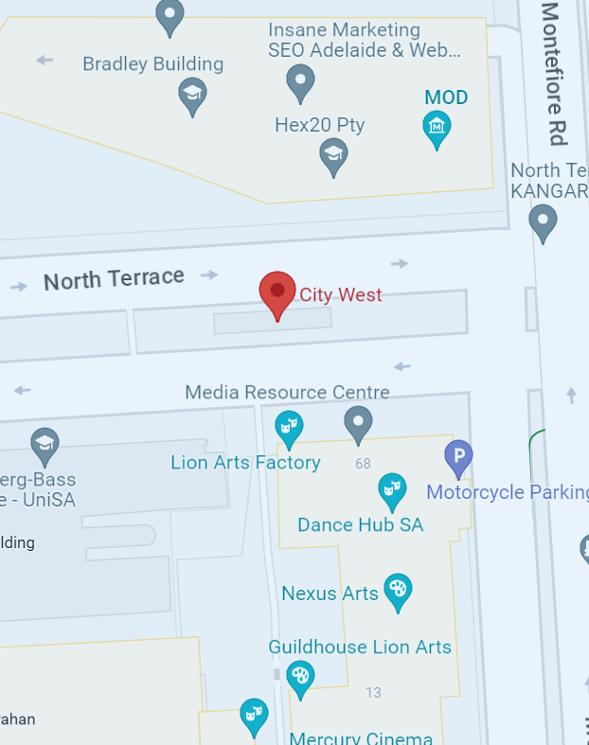
The closest tram stop is City West on North Terrace.
It is about 70m away from Nexus Arts.
When you get off the tram, you must cross to the South side of North Terrace. There is a crossing with lights.
Then you follow the steps under FROM THE SOUTH SIDE OF NORTH TERRACE written above.

BY BUS
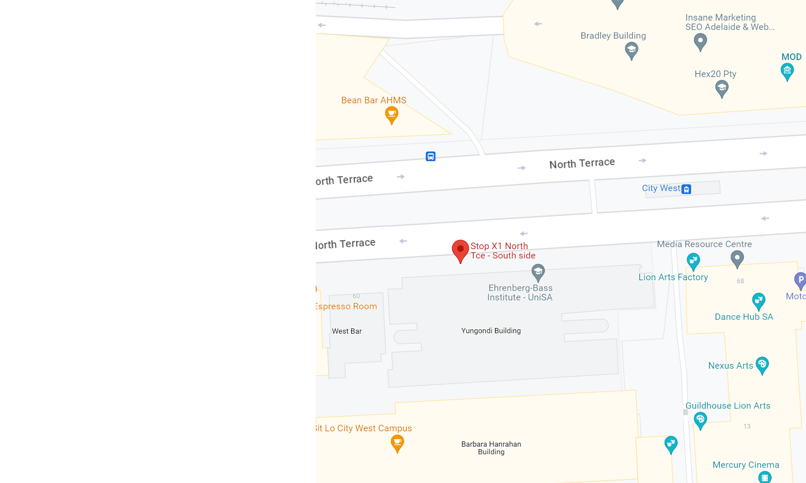

The closest bus stop is X1. It is on the South side of North Terrace.
It is about 70m away from Nexus Arts.
Nexus Arts is a short walk away from bus stops on Grenfell Street. Follow the steps under FROM THE WEST SIDE OF MORPHETT STREET written above.

BY TRAIN

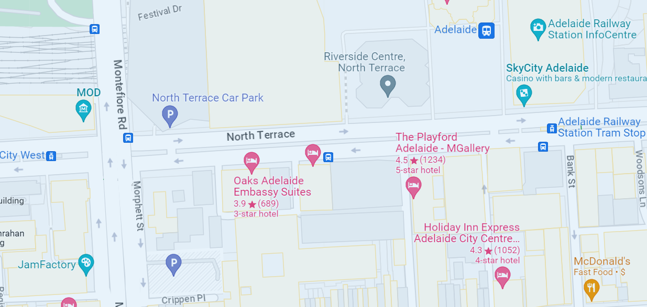
You can walk from Adelaide Railway Station to Nexus Arts. It will take about 10 minutes.
When you leave the railway station, you turn right onto North Terrace.
Then head West for about 600 metres and cross the road to the South side of North Terrace.
Then you follow the steps under FROM THE SOUTH SIDE OF NORTH TERRACE written above.

BY BIKE
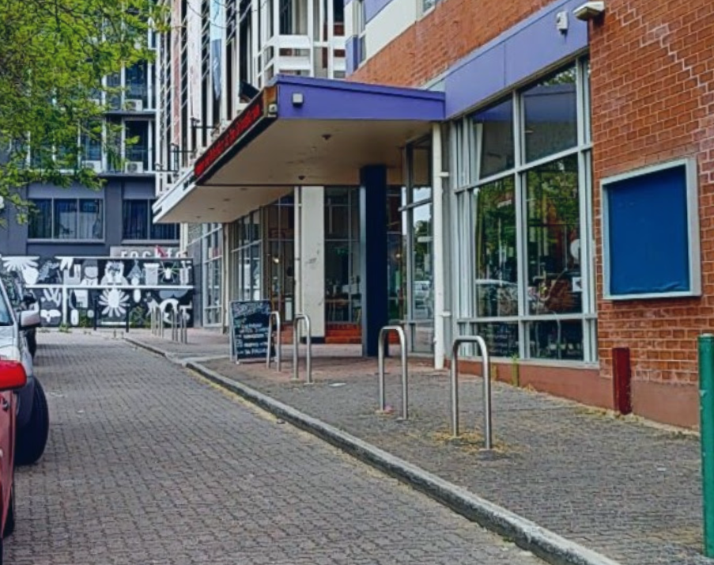
There is bicycle parking at the Morphett Street entrance.
It is in front of the Jam Factory and Mercury CX buildings.

BY MOTORBIKE

There is motorbike parking under the bridge at the Morphett Street entrance.
It is opposite the front of the Jam Factory and Mercury CX buildings.

BY CAR
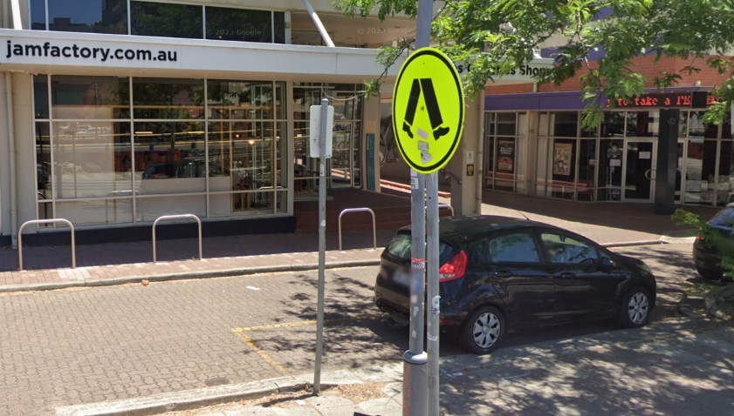
There is an accessible car park at the Morphett Street Entrance.
It is in front of the Jam Factory and Mercury Cinema.
There is a limited amount of street parking spaces. You need to buy a ticket for these.
There are many pay-by-the-hour car parks located on Hindley Street. Both to the East and West of the Lion Arts Precinct.
IF YOU NEED HELP YOU CAN:

CALL NEXUS ARTS on (08) 8212 4276.

EMAIL NEXUS ARTS on info@nexusarts.org.au

